**Lesson 6 Demo 4**

**Connecting Applications with Services**



Steps to be followed:

1. Exposing the pod to the cluster
2. Creating a service for the deployment
3. Accessing the service

**Step 1: Exposing the pod to the cluster**

* 1. Create a pod configuration file using the following command:

***vi exposing-pod.yaml***



* 1. Add the following code to the file created:

***apiVersion: apps/v1***

***kind: Deployment***

***metadata:***

***name: my-nginx***

***spec:***

***selector:***

***matchLabels:***

***run: my-nginx***

***replicas: 2***

***template:***

***metadata:***

***labels:***

***run: my-nginx***

***spec:***

***containers:***

***- name: my-nginx***

***image: nginx***

***ports:***

***- containerPort: 80***

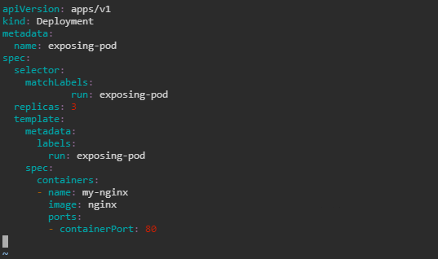

* 1. Create a resource for the pod using the following command:

***kubectl apply -f exposing-pod.yaml -n test***



* 1. Check the node the pod is running on with the following command:

***kubectl get pods -l run=exposing-pod -o wide -n test***

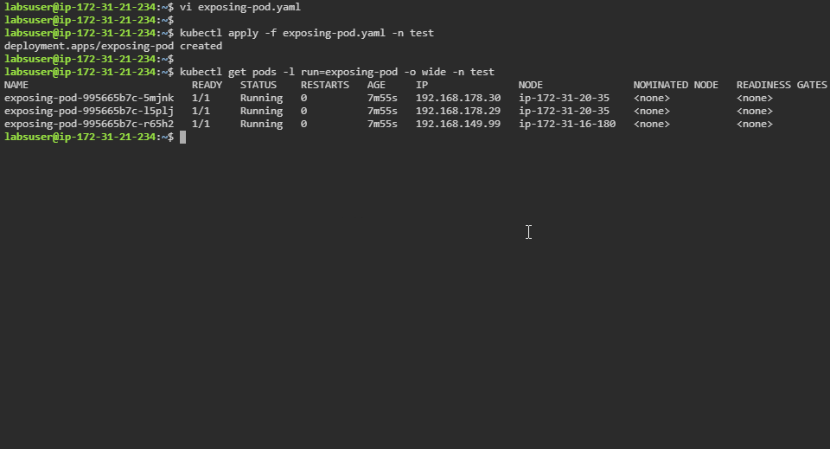

**Step 2: Creating a service for the deployment**

1. Create a service using following command:

***kubectl expose deployment/exposing-pod -n test***



* 1. Check the newly created service

***kubectl get svc exposing-pod -n test***

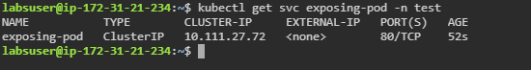

* 1. Fetch the endpoints for the service

***kubectl get ep exposing-pod -n test***

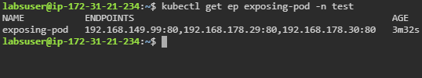

**Step 3: Accessing the service**

1. List all the runnings pods in test namespace

***kubectl get pods -n test***

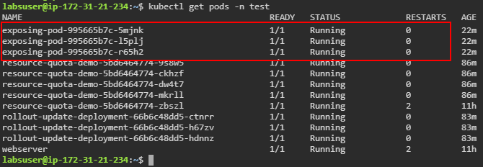

1. Use the following command to inspect the environment of any one of the exposing-pods:

***kubectl exec exposing-pod-995665b7c-5mjnk \***

***-n test -- printenv | grep SERVICE***

